Our video

# Ideas

* Audience: a dashboard for the ATO and other government departments to help visualise what suburbs will look like in 2030. This includes:
  + Who will be living in the suburb?
  + What are their life prospects?
  + What is their economic contribution?
* We have combined datasets from:
  + The Australian Taxation Office (ATO)

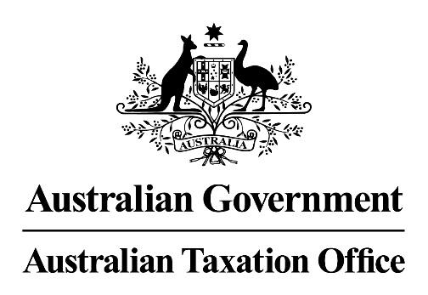

* + The Australian Bureau of Statistics (ABS)

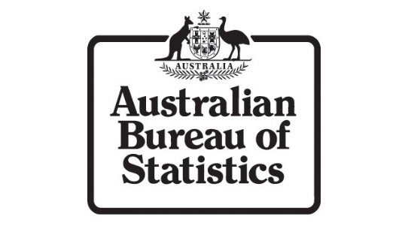

* + The South Australian Attorney-General's Department (AGD)

[](https://data.sa.gov.au/data/organization/attorney-general-s-dept)

* + The Department of Planning, Transport and Infrastructure (DPTI)

[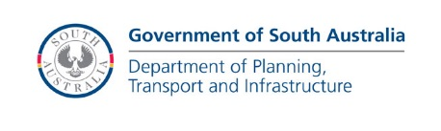](https://data.sa.gov.au/data/organization/department-of-planning-transport-and-infrastructure)

* + The Department for Education and Child Development (DECD)

[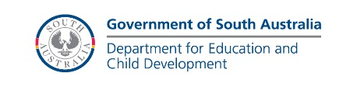](https://data.sa.gov.au/data/organization/dept-for-education-and-child-development)

* This includes the following datasets:
  + <list here>
* This visualisation will serve multiple purposes:
  + Help the ATO identify which suburbs are changing their economic profile and therefore their taxation profile
  + Help the AGD identify which suburbs are at risk of increased crime rates
  + Help the DPTI identify which suburbs could benefit from an increased focus on infrastructure
  + Help the DECD identify which suburbs could benefit from additional funding in schools and extracurricular programs to prevent youth delinquency and improve educational prospects
  + Help other government departments identify which suburbs could benefit from an increased focus on health promotion and crime prevention programs
* X

Introduce team name and members

Aim of hack

Dataset

Technologies used

Where is hack hosted

Key expertise that went into it

Interesting datasets being combined

Screenshots, video and voiceover

Plan your demo

Describe missing features and what we ould do next

Who does it benefit, whose life does it improve

Add progress shots if available

Produce at 720HD – 10 minutes to render

# Project description

Suburb Outlook is a forecasting tool designed to assist government authorities with making forward-thinking and informed decisions about the future development of a given suburb.

Our goal was to bring together as many datasets as possible from different sources to help visualise the economic and social make-up of a given suburb. We then extrapolated the existing 2006-2015 data to present the outlook of each suburb as it might appear in 2030. Due to the limited timeframe of the GovHack event, we limited ourselves data visualisations for

For these data visualisations, we have brought together datasets from:

* The Australian Taxation Office (ATO)
* The Australian Bureau of Statistics (ABS)
* The South Australian Attorney-General's Department (AGD)
* The Department of Planning, Transport and Infrastructure (DPTI)
* The Department for Education and Child Development (DECD)

Suburb Outlook will serve multiple purposes:

* Help the ATO identify which suburbs are changing their economic profile and therefore their taxation profile
* Help the AGD identify which suburbs are at risk of increased crime rates
* Help the DPTI identify which suburbs could benefit from an increased focus on infrastructure
* Help the DECD identify which suburbs could benefit from additional funding in schools and extracurricular programs to prevent youth delinquency and improve educational prospects
* Help other government departments identify which suburbs could benefit from an increased focus on health promotion and crime prevention programs

Suburb Outlook is targeted at the following Awards:

* **Bounty: Plausible Futures**: this bounty was the main driver behind the creation of Suburb Outlook. Our objective was to extrapolate available trend data on many aspects of a suburb to provide government agencies with the most comprehensive and accurate set of predictions possible.
* **Bounty: .tech / .space**: the suburboutlook.tech domain name is a great place for our website as Suburb Outlook uses technology to enhance government decision-making.
* **Best Entry from South Australia**: we believe Suburb Outlook will be of significant value to the South Australian government in helping to shape the future of South Australia’s suburbs by identifying positive and negative trends and implementing remedial actions in a timely fashion. Suburb Outlook uses multiple datasets from data.sa.gov.au, including population projections, crime mapper data, median house sales data and the Australian Early Development Index.
* **Neighbourhood and Community Confidence**: Suburb Outlook integrates crime mapper data from the Attorney General’s Department with the Australian Early Development Index to help identify suburbs where youths are most vulnerable and therefore most at risk of experiencing poorer educational, social and legal outcomes, which would in turn impact on crime rates in these suburbs. The combination of these datasets could help inform the Attorney General’s Department and SA Police as to which suburbs would most benefit from additional crime prevention programs and police resources, thus improving quality of life for the residents of these suburbs.
* **Numbers hack**: Suburb Outlook is very much grounded in government data and trend analysis and extrapolation. Despite the limitations of the available aggregated data and the timeframe of the GovHack event, we have attempted to create realistic projections of income, childhood development, house prices, cultural diversity and crime rates for a selection of Adelaide suburbs. The Excel spreadsheets supporting the creation of the data visualisations are available from our website.
* **Places hack**: …
* **Smart Lifestyles**: …